1. 𝐹(𝐴, 𝐵, 𝐶) = ∏(0,2,3,6). Derive the equation of F.  
   a) Using first canonical form. Simulate the circuit.  
   b) Using second canonical form. Simulate the circuit.  
   c) Using K-map. Draw the circuit.  
   d) Draw the IC diagram of the circuit you get from question c.

**Answer To The Question No 1**

**(a)**

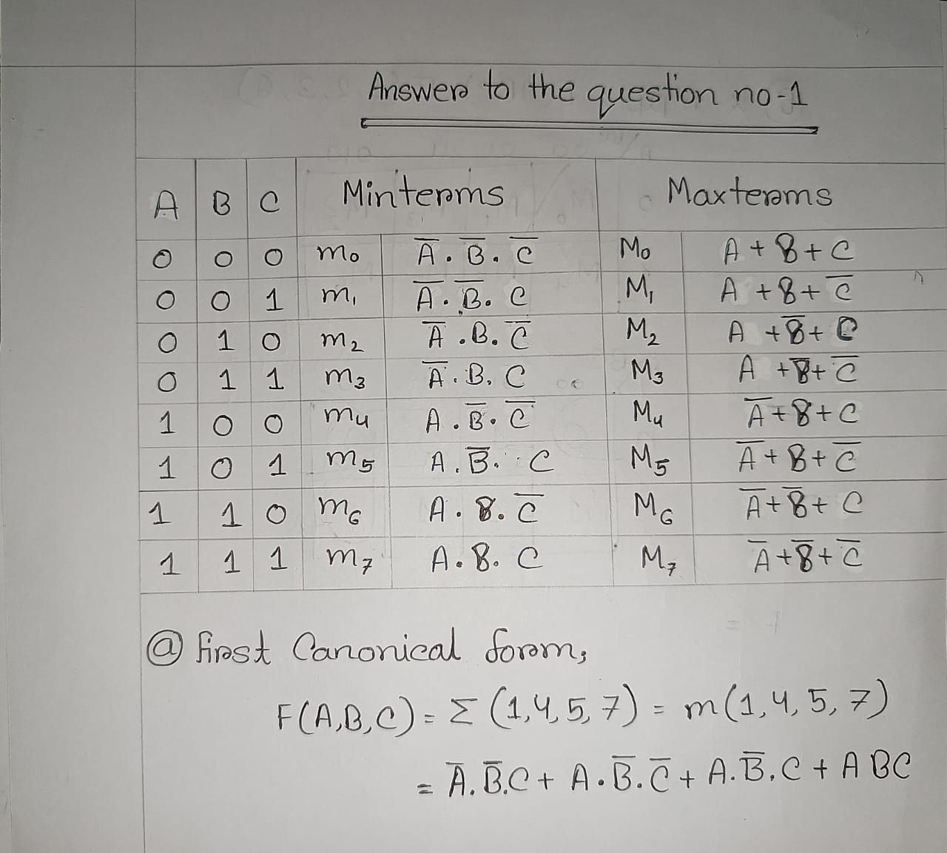

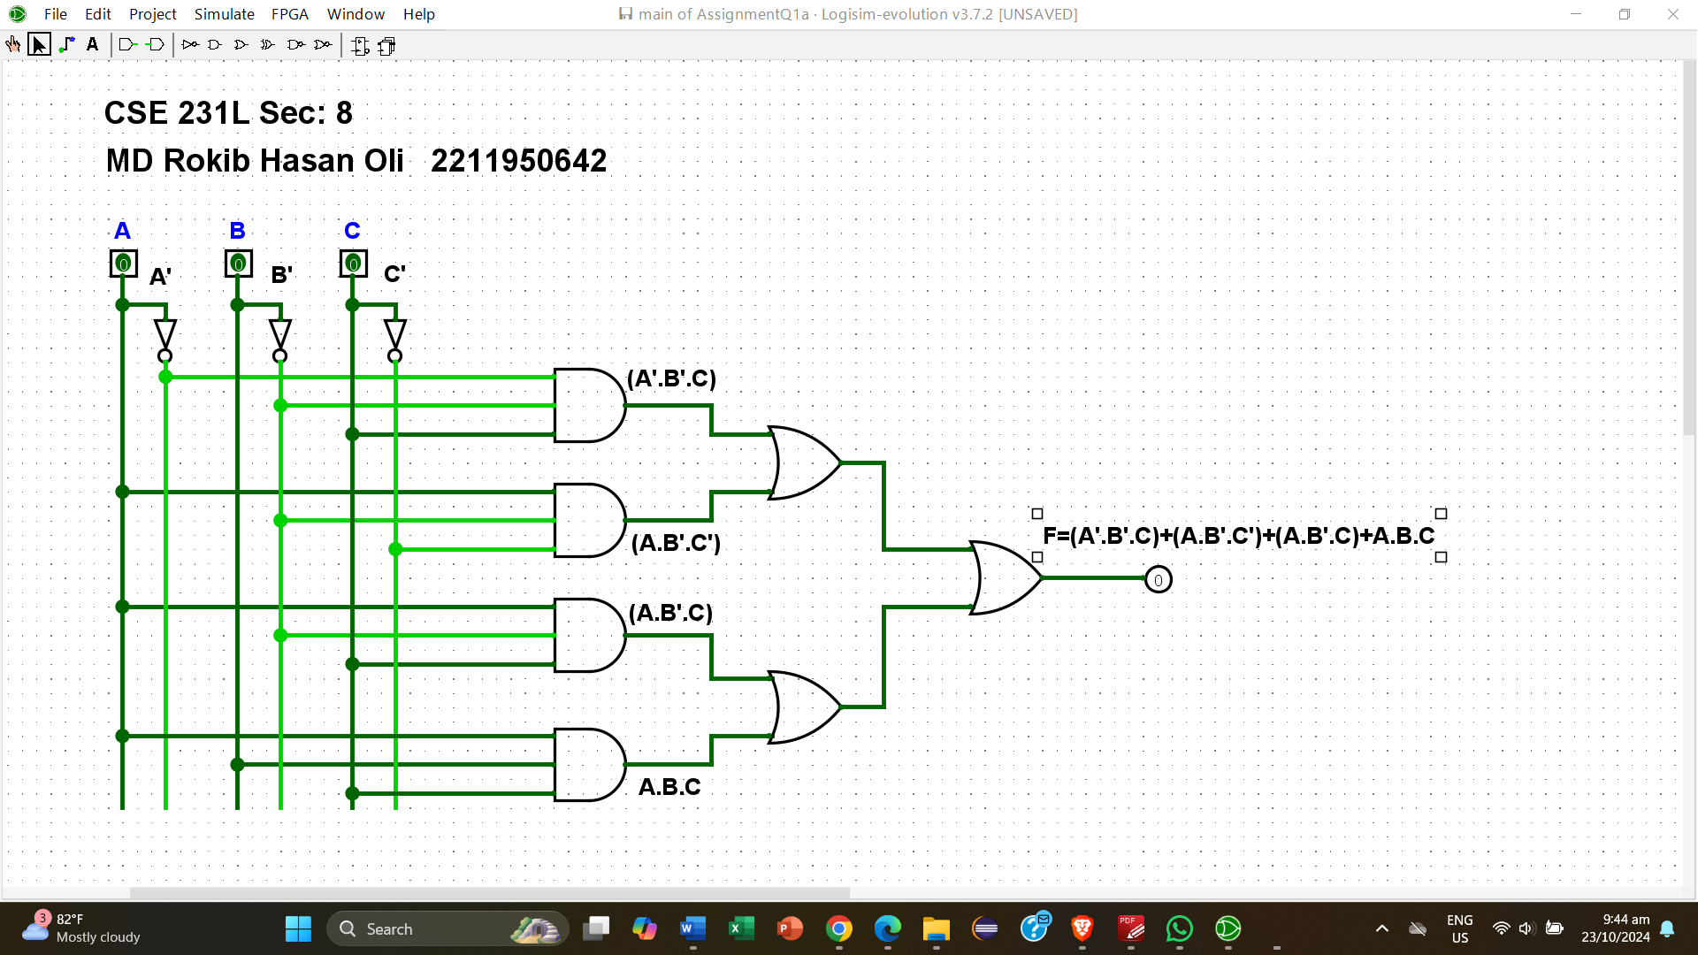

**(b)**

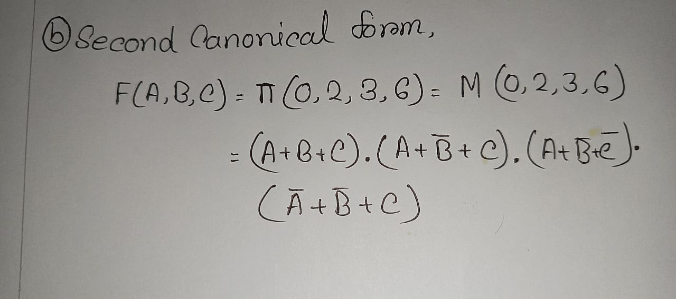

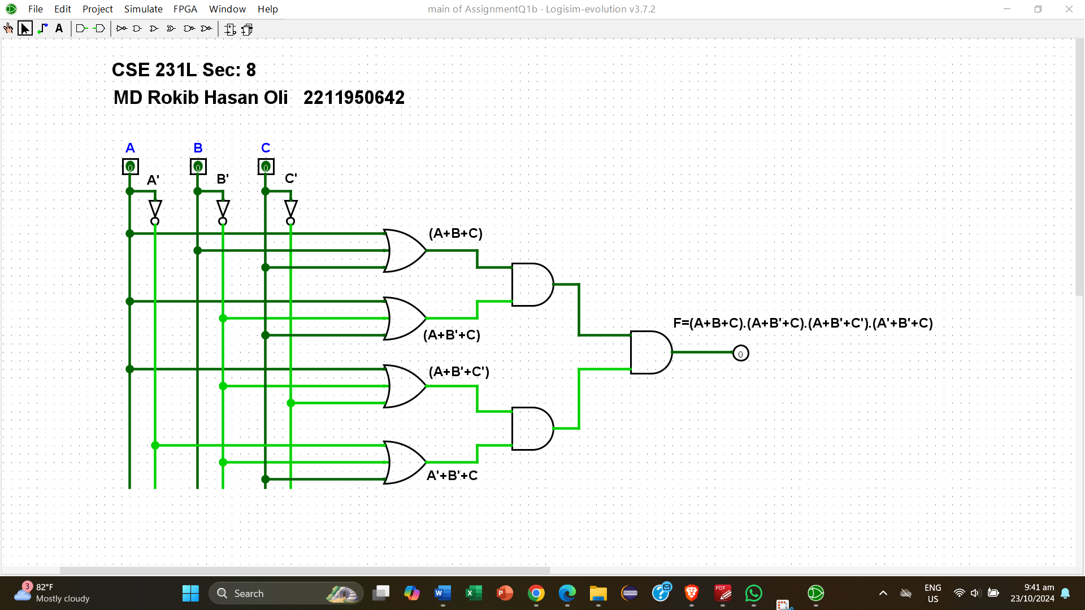

**(c)**

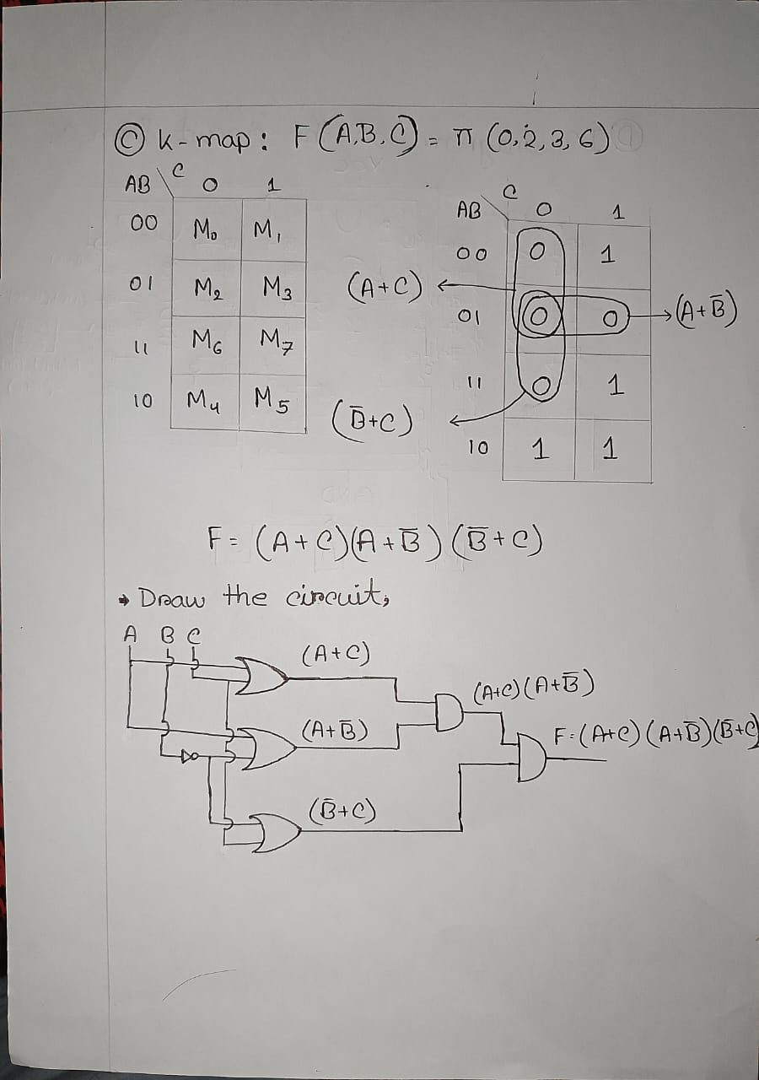

**(d)**

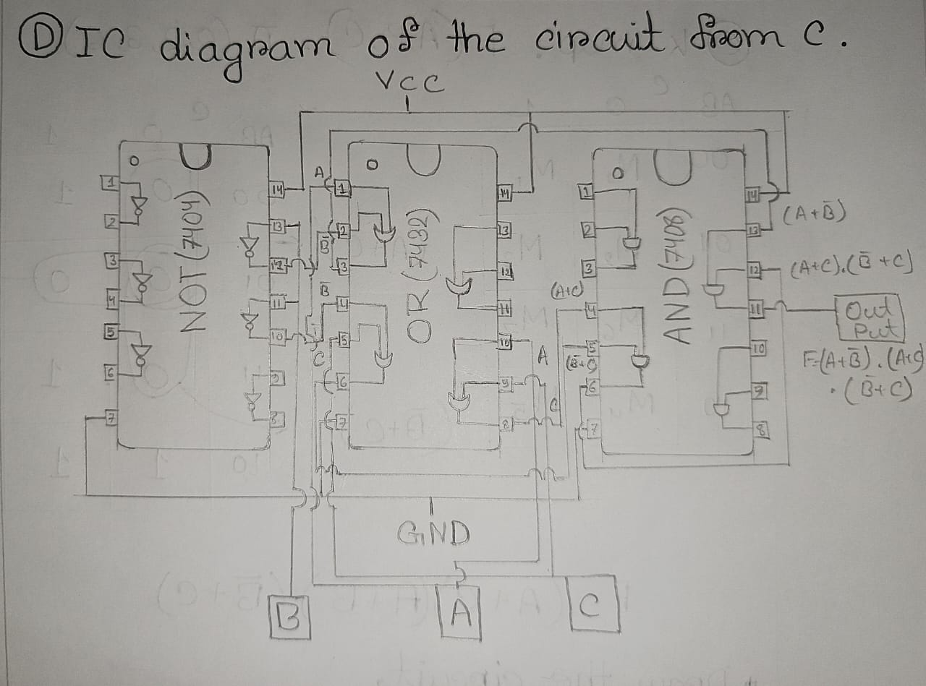

2) 𝑃(𝑊, 𝑋, 𝑌, 𝑍) = ∑(0,1,4,5,9,11,13). Derive the equation of P  
a) Using first canonical form.  
b) Using second canonical form.  
c) Using K-map. Simulate the circuit.  
d) Convert the circuit of question c to its NAND equivalent circuit.  
e) Convert the circuit of question c to its NOR equivalent circuit.  
f) From question a to e which is the most cost-effective circuit. Justify your answer.

**Answer To The Question No 2**

**(a)**

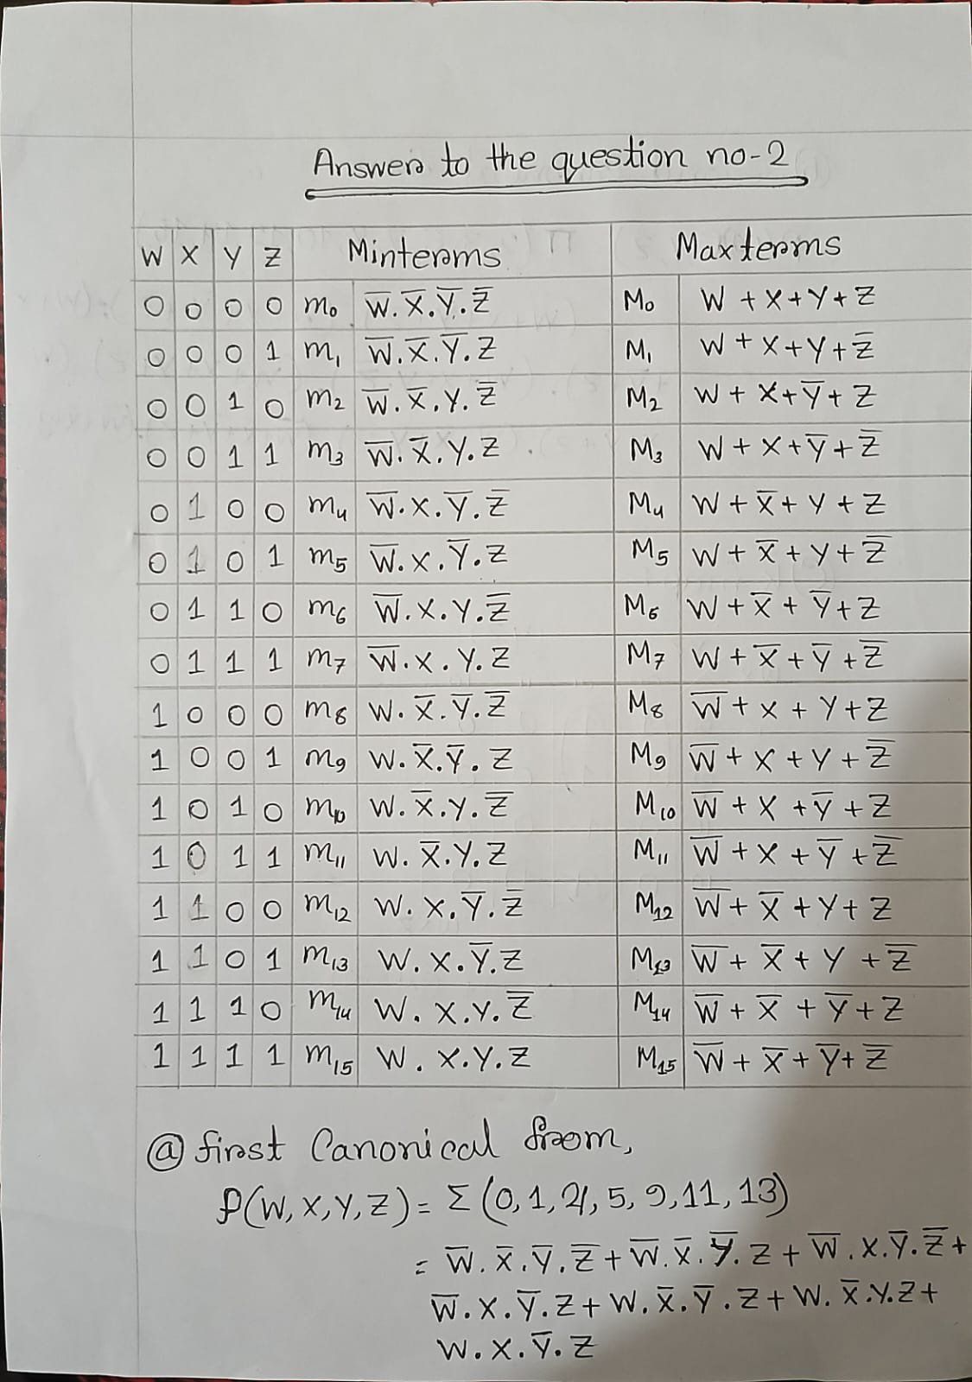

**(b)**

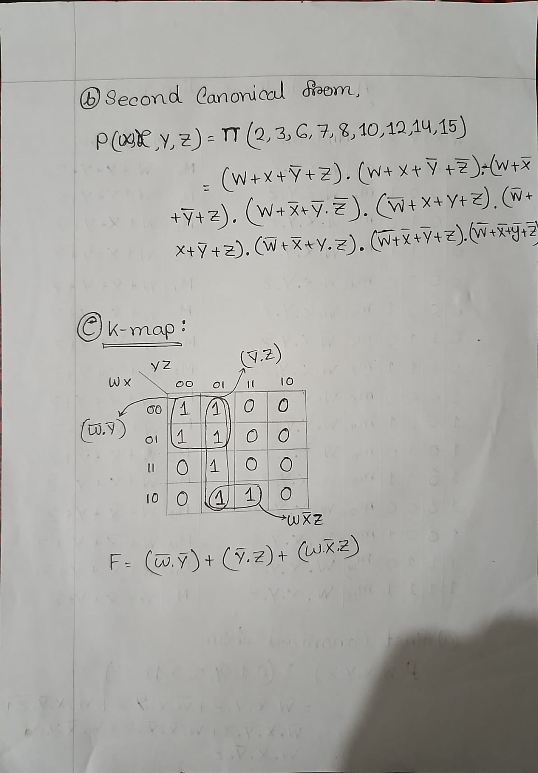

**(c)**



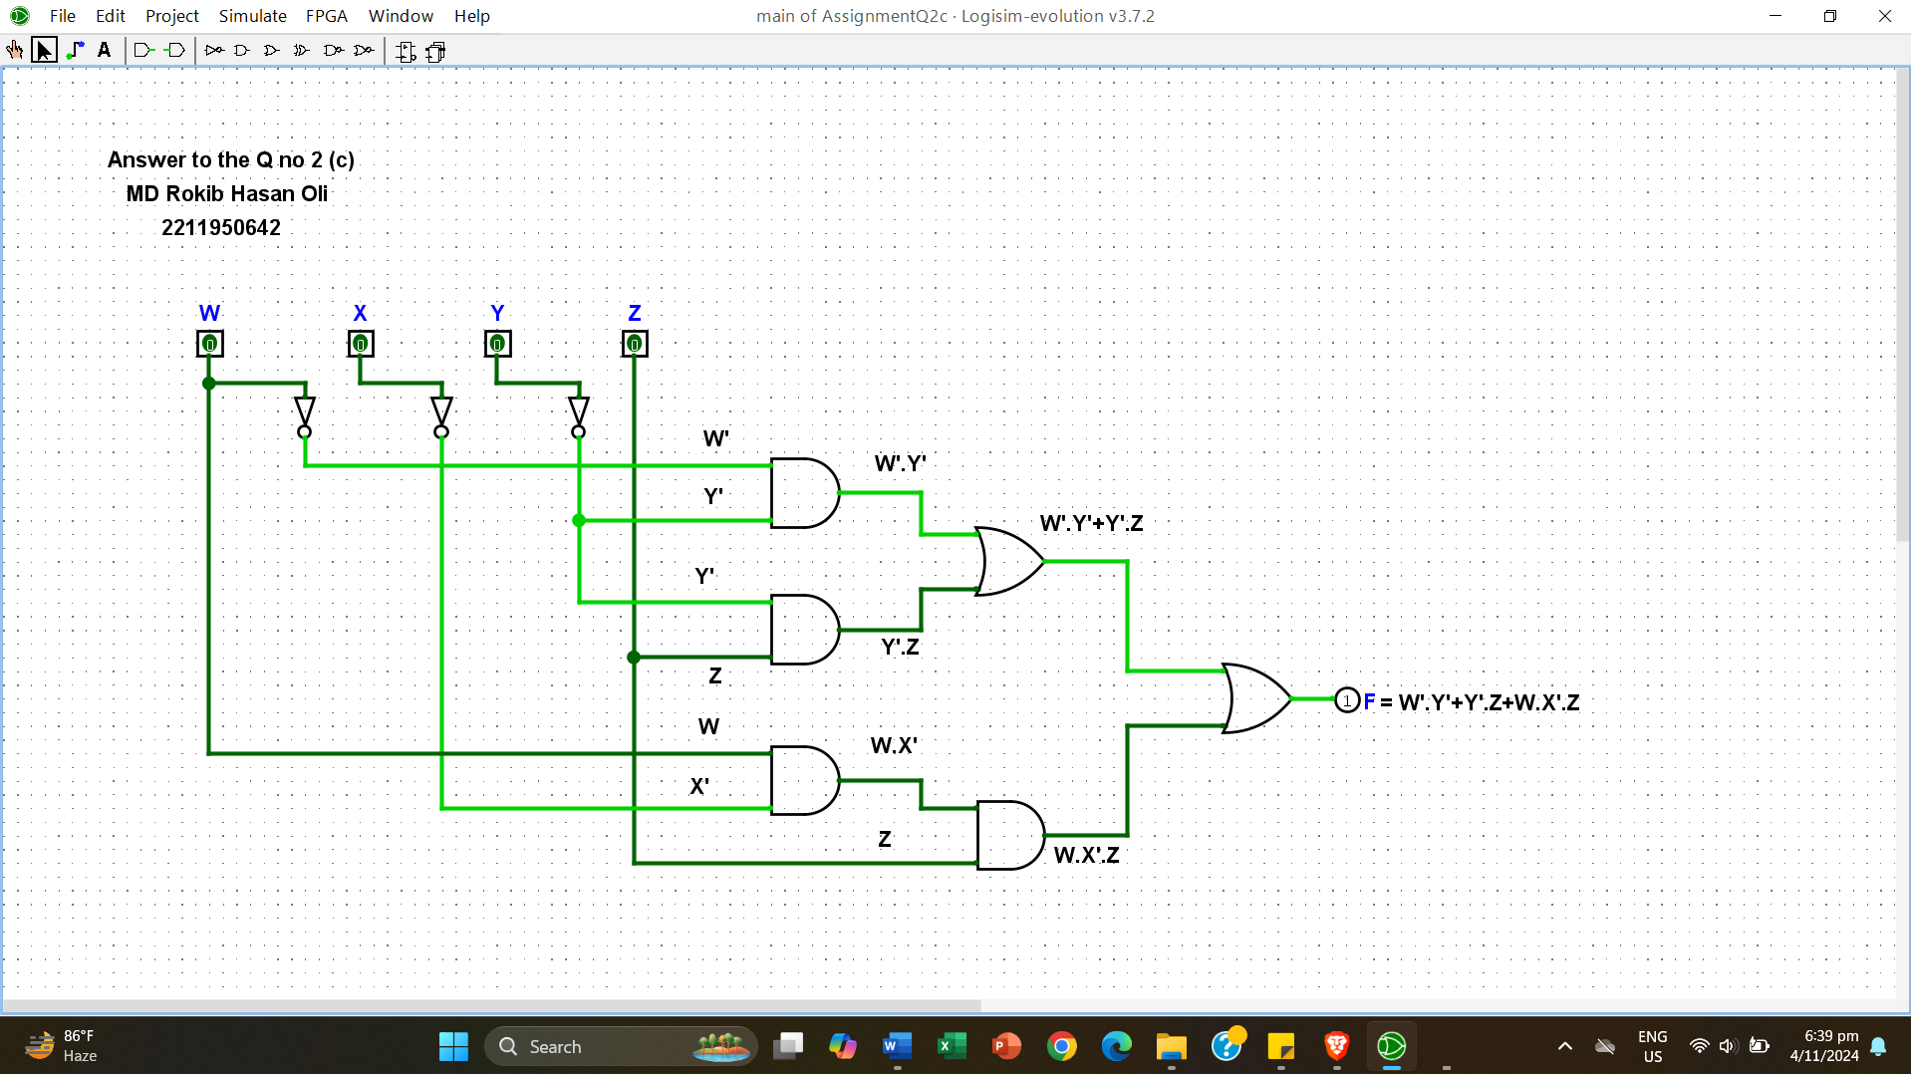

**(d)**

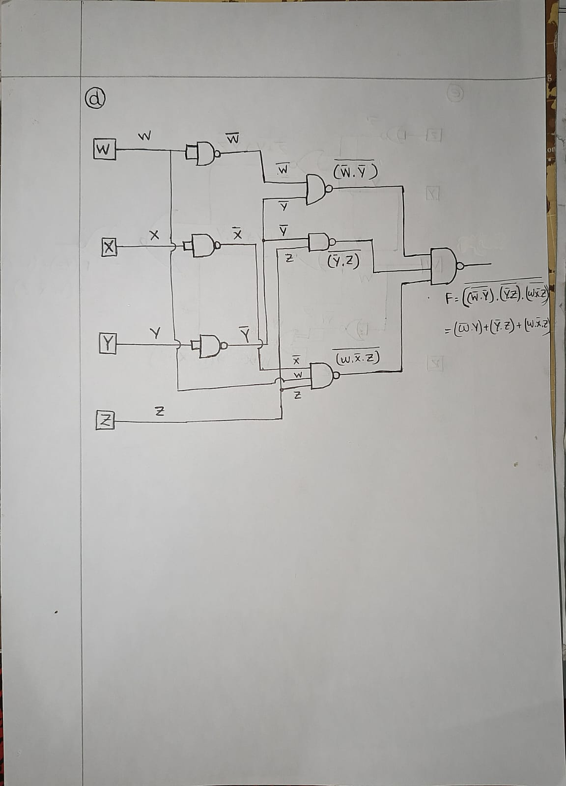

**(e)**

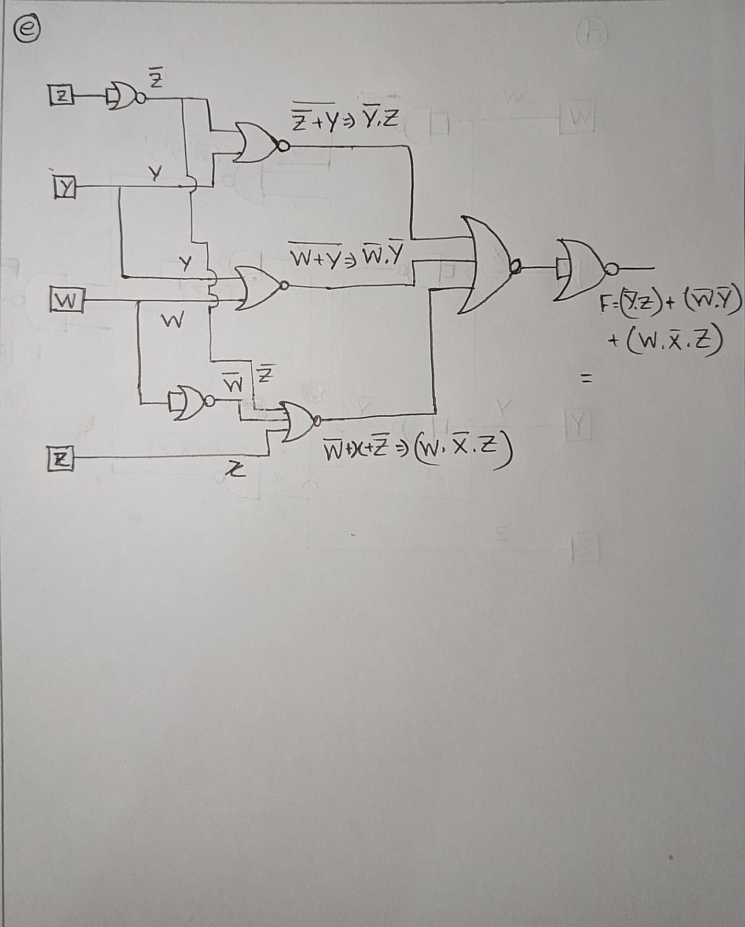

**(f)**

